Sercombe, Nigel (mainly based on Linked In)
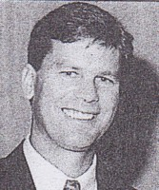
Worked for Forests Department in goldfields region in 1978 on wages. Graduated from Dwellingup Cadet School (now Training Centre) in 1980. First posting as Forest Guard in Walpole, then Manjimup. Managed Broome tree nursery in 1983. Resigned from Forests Department in 1984 to undertake theological studies. During these studies (3 years) he was a youth worker with a church in Perth. Returned to CALM in 1988, based in Manjimup as Forest Ranger Operations then went to Dwellingup as a training officer. Promoted to Forester (Dwellingup) in 1989. In 1992 transferred to Midwest Region as regional operations officer. Later promoted to Regional Manager. Has a Diploma of Management from Challenger College of TAFE in Fremantle and a graduate business qualification in Business Administration. Won 2001 Seamus Mulholland Scholarship, which will facilitate him to obtain a Master of Business Administration at Curtin University. Has done teacher training.

